NEWSLETTER OF THE ZONTA CLUB OF BUNDABERG INC.
QUEENSLAND - AUSTRALIA

“Advancing the Status of Women Worldwide”
Club No 1296 Area 4 District 24, Charter 24.08.90

Postal Address: PO Box 431, Bundaberg 4670.

July 2006

President: Judy Bedford Secretary: Anne Nelson Editor: Dianne Leggo
Home Ph: 07 4152 4783 Home Ph: 07 4159 0714 Home Ph: 07 4154 7958
judy.bedford@bigpond.com gables5@bigpond.com dleggo@aapt.net.au

PLEASE NOTE PRESIDENT JUDY’S NEW EMAIL ADDRESS!

AUGUST DINNER MEETING

Same new venue as last month! Tuesday, 6 June, at Across the Waves Club, Cnr Thabeban & Ritchie Streets at 6.30pm for 7.00pm. $20.00. No apology by 10.00am on the day of the meeting - you will receive an invoice for the cost of the dinner.
APOLOGIES for August meeting to Judy Bedford, phone 4152 4783 or email judy.bedford@bigpond.com

Rosters: Door: Lee Fleming & Jean Gahan; Blessing: Denise Tomlin

Happy Birthday in August to: 13th Helen Cook, 21st Shirley Kidd

Dates to remember:
5 August Market stall at Bundaberg Port Marina – see Finance segment below and contact Robyn Dyer if you can help.
11 August “Key for Two” at the Playhouse - $15. Contact Lee Fleming.
9 & 10 Sept. Birthing Kit Workshops at CQU.
11 March 2007 – IWD Breakfast
28/29 April 2007 – Area 4 Meeting at Hervey Bay.

WANTED
- A Club Archivist – contact President Judy.
- Items for Phoenix House – see “Status of Women Service Committee” on page 2.
- Material for Breast Cushions – contact a member of the SWS Committee if you have any fabric that might be suitable.
- Does anyone apart from Dianne have any made-up cushions?
- Anyone interested in serving on the Nominating Committee? Please arrange for someone to nominate you at the August meeting elections.

Message from President Judy
At our July Dinner Meeting it was great to welcome Annette Baldry, Deltry Dickie, Joan Hawe and travelling Zontion Carol Christensen and our guests Kirsty Broun and Lyn Murray.

Our Board meeting last Tuesday 18 July was attended by all members. Committee reports indicated how busy the committee members have been. Thank you.

With August fast approaching and a busy month for us. Finance and Fundraising Committee members have organized tickets available for a Playhouse Theatre comedy performance “Key For Two” on Friday 11 August 2006. It will be a great social night for members and guests and a very easy fund-raiser. Status of Women and Service Committee members have proposed two days in August for assembling birthing kits. After some persistance from the Public Relations Committee member Jean our club was mentioned in the news-mail on Wednesday 12 July. United Nations Committee members are busy preparing for International Women’s Day Function in March 2007. Program Committee members are very much in touch with a review of our meeting venue. Organization and Membership Committee members have been busy with “Member Maintenance”- updating our membership list, keeping in touch with members who have been unwell and also our guests Kirsty and Lyn.

To those members who have been unwell or who have family members unwell, I wish you all the very best and those of you who are travelling for work or holidays have a safe journey.

Looking forward to seeing everyone at our Dinner Meeting next Tuesday 1 August 2006.

Judy

Programme Committee
Meeting venue as per last month. Committee is reviewing the situation.

Membership Committee
Lyn Murray will come again as a guest.
New updated Club Manuals are going to be printed. Please order from Trish Eussen at August meeting or by email if you would like one. Cost – To be notified

Status of Women Service Committee
Tracksuits, underwear and toiletries are to be brought August dinner meeting. These will be given to Phoenix House for rape victims who have to undergo forensic testing.
Please consider a proposal for future donations which will be forwarded to members before next meeting.

Finance Committee
“Key for Two” at the Playhouse, $15, contact Lee Fleming for tickets.
A Market stall is planned at Bundaberg Port Marina on Saturday, 5 August from 1pm to sell left-over scarves and craft items from Convention. Volunteers needed. Please contact Robyn Dyer if you can help.

Member News
- Our love and thoughts are extended to Dianne Leggo who has been spending time with her sister. in Victoria
- Loving thoughts and best wishes go to Wilma Berry who had a bypass operation in Brisbane this month.
- Great to see Linda Adcock looking so well so quickly after her sudden appendix op.
- Rachael Baker & baby Penny have been sick with the flu. We hope you are both better very soon.
- Denise Tomlin’s daughter and family are shifting home to Bundy. Best wishes for complete recovery to Denise’s son in law.
- Michelle Brown has booked to go to Italy, Switzerland & England in October – very exciting!
- Robyn Kirby had 2 weeks holiday post Convention in Manly, the Blue Mountains and a sleep-over at the Dubbo Zoo!
- Good luck to Trish Eussen who is studying for her Certificate IV in Frontline Management.
- Congrats to Dianne Leggo who became a grandmother this month to Alexander Blake in Adelaide, and to Judy Noble who welcomed her sixth grandchild.
- Judy is still in Brisbane while John has treatment and Dianne is in Melbourne with her sister and Adelaide to meet the new baby.

Please note change of Birthing Kit Assembly dates. 9 & 10 September. Central Queensland University. More news at our dinner meeting on Tuesday.

Please accept my apology for the late delivery of the newsletter. Robyn K

ZONTA CONVENTION PICTURES

2 young ones – Jen Leggo & Wendy from California.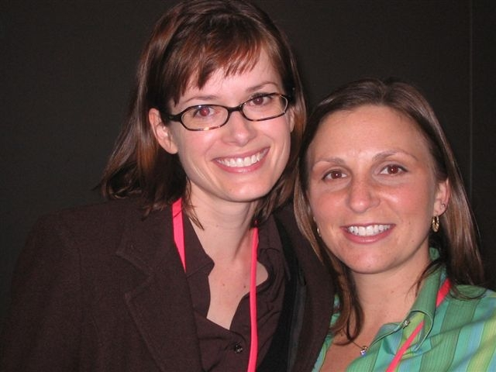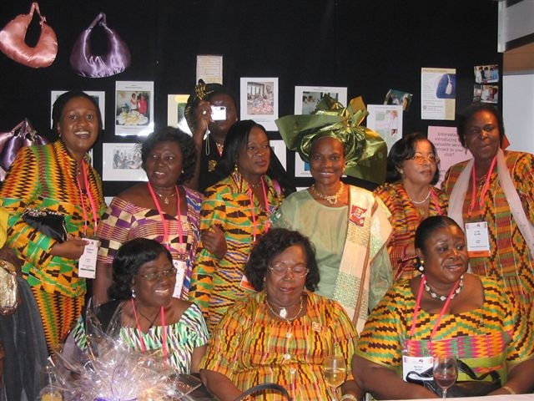A colourful group from Africa
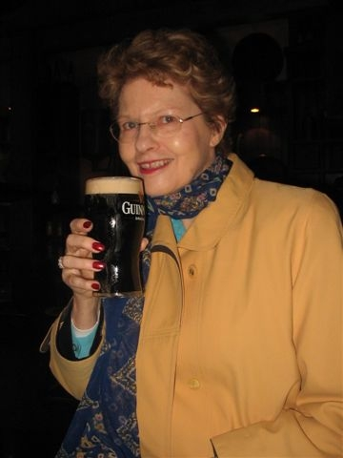
Dianne drinking again!

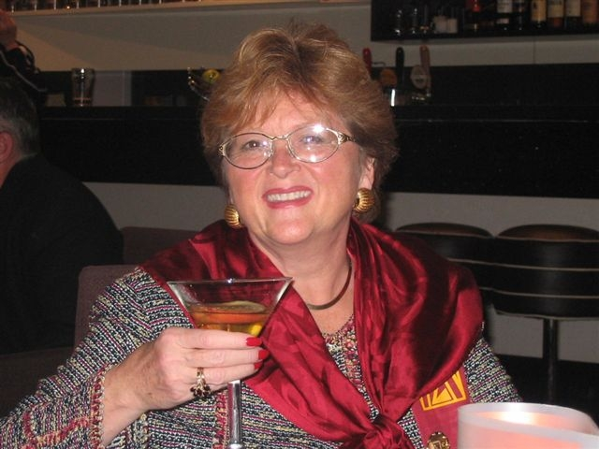
New Intl. Director Bonny Schumacher from California
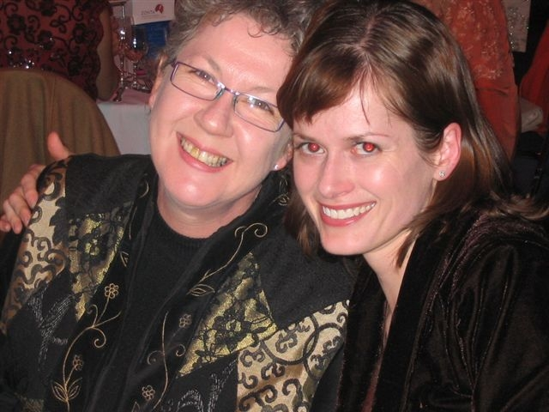
New friends Robyn K & Jen Leggo
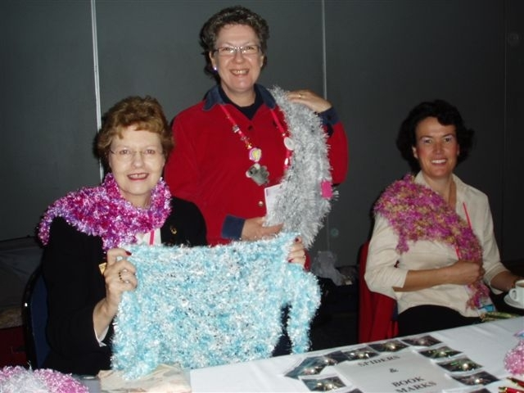
Dianne L, Robyn K & Elizabeth H at the marketplace.

