ZONTA


Contacts

President
Larraine Smith
47 851230
lfsmith0@tpg.com.au

Treasurer
Bon Wharley
47 861538
acemowers@westnet.com.au

Secretary
Angela Cornwell
47 861496 (H)
47 913 111 ext 114 (W)
acdc@tpg.com.au

Attendance
Therese Mayhew
47 852677 (H)
47 852218 (W)
tmayhew@tpg.com.au

Editor
Rhonda Nilsson
0438 756233
nilsson2@bigpond.com

District 24 Website:
http://www.zontadistrict24.org
Zonta International Website:
http://www.zonta.org

Bowen Zonta Club Inc
Club 1476 Area 7 District 24

President’s Report
Tonight we need to vote on the motion: which was recently received from District 24 Governor Ros:
That District 24 be divided into two Districts at the Qld / NSW border and that the division if approved by the clubs take effect from the 2006-08 biennium i.e. immediately post convention 2006 and that the funds of the district be divided on a pro rata basis based on membership as at 31 January 2006.
There are pros and cons for this which we will discuss before voting.

While on the subject of voting, tonight we also have
to elect our voting delegate for the 2006 Convention in Melbourne.

Nominating Committee
The Handover Dinner is planned for Sat 17 June.
Slate of Candidates – March 2006

President Rhonda Nilsson Accepted

Immediate Past President Laraine Smith

Vice President 1
Bev Lowcock Accepted

Vice President 2
Therese Mayhew Accepted

Directors Laraine Smith Accepted
Jan Pearce Accepted

Secretary Angela Cornwell Accepted

Treasurer Lyn Allison Accepted

Asst Treasurer Bon Wharley Accepted

Standing Committees:
Finance & Fundraising Leonie Cunningham Accepted

Status Of Women Sue Wagner Accepted

Program/Attendance/ Lorraine Rowan/ Accepted
Raffles Carol Ann Barrett Accepted

Membership Lynette Klukas Accepted

PR & Communication Cheryl Vennard Accepted
& Newsletter

Special Committees:
Archives Linda Tickle Accepted

United Nations Hortense Ingram Accepted

Attendance Lorraine Rowan Accepted

Stock Sales Margaret Sallway Accepted

Status of Women Committee Report
Meeting held at Rhonda’s on 4 April – discussed success of IWD Luncheon.
More breast cushions have been ordered to restock at Bowen and Collinsville Hospitals and 4 Medical Centres in Bowen.
We have applied for another grant from Office For Women, which, if successful, will fund a business women’s brunch in September.
Rhonda

Finance and Fundraising Committee Report
Reminder that we are each to provide 10 prizes for the Monster Cent Sale on 13th May at the Bowen Sailing Club.
Membership Committee Report
nil
Program Committee Report
- The Guest Speaker is in place for the April Dinner Meeting.
- There will be no guest speaker for the May meeting due to a heavy program already.
- Plans are underway for our June Handover Dinner which will include Guests from out of town being invited.
- All members are asked to make a special effort to bring guests to this dinner.
- Some forward notice of attendance would be appreciated as we are looking to being able to have the large function room at the Castles, dependent on numbers. However they naturally require some notice of this.

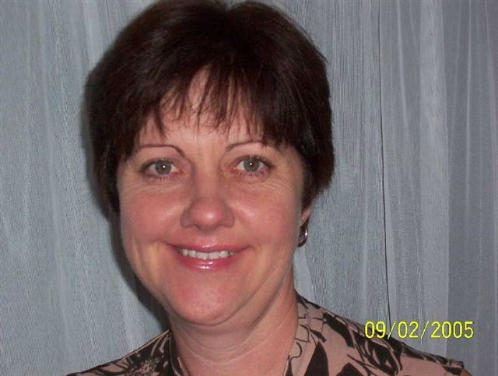

Profile –

Therese Mayhew

I am a local girl, born in Bowen on the 25th June 1961, the fourth and youngest child of Noel & Madge Pilcher.

I attended St. Mary’s for my primary schooling and then on to St Patrick’s College in Townsville as a boarder where I completed Year 10 in 1976. I commenced work in December of that same year as an office junior at Michael’s Hardware which is now known as Pilcher Industries Mitre 10.

It was not long after this I met Russell Mayhew and we were married is December 1980. I was nineteen!!!

We moved to Collinsville for the next six years after Russell secured employment at the Power Station. I too worked at the Collinsville Power Station, firstly in admin then in the laboratory, doing mainly coal and water analyses.

Michele, the eldest of our 3 daughters was born in 1986, followed by Tracey in 1988 and Jenna in 1991.

We were living back in Bowen when we started our own business RTM Engineering in 1990. From the early days of that first little shed with Russell “on the tools” and me doing the accounts the business has grown considerably. We are still in the same location along Collinsville Road however the workshop and office areas have expanded and we now employ 30 permanent staff. As the name suggests we are a general engineering company. We have just added a retail sales section to our operation stocking engineering and agricultural supplies.

I am involved in the day to day management of the business which leaves me very little “spare” time.

I have been involved with the Bowen Lions Club for nineteen years. I am not a Lions as such but a Lions Lady (partner of a Lion). The ladies have their own auxiliary club which plays a support role to the men and their Lions projects, the main one each year being the Coral Coast Charity Festival.

I’ve been lucky enough to have enjoyed four overseas holidays. As a family we visited the USA in 2000. Imagine Christmas day, New York City, snow everywhere. It was wonderful! In 1984 Russell & I spent a few weeks in Hong Kong & Singapore along with my sister and her husband. And in my younger years I visited Fiji and New Zealand. I enjoy traveling overseas and plan to do more of this in the coming years.

So, life is good. I’m healthy and happy, as is my family. Who could ask for more!

Diary Dates

3rd May- Board Meeting
10th May – Dinner Meeting
13th May – Cent Sale
17th June – Handover Dinner
13-14 May 2006, Area 7 Meeting, Townsville
24-29 June 2006
58th International Convention, Melbourne

Please remember to notify Therese if you have an apology or are intending to bring along a Guest.

