
BeauZontian
ZONTA CLUB OF BEAUDESERT AREA

AREA 5 DISTRICT 24

ISSUE: 223 MARCH 2008

GENERAL DINNER MEETING
Tuesday, 18th March, 2008

Guest Speaker this month: Constable Pauline Guise

Cost of Dinner: $20 - Please try to have the correct change

BOARD MEETING 5:00 pm

COMMITTEE MEETINGS 5:45 pm

DINNER MEETING 6:30 pm

APOLOGIES

Apologies are to be directed ONLY to Ellen Logan on 55431 223.
Please advise by 5 pm Monday 17th March, 2008.
In case of an EMERGENCY, an apology may be accepted by
Ellen (0408 431 223) up to 8:30 am on the day of the meeting.
An account for the cost of the dinner will be forwarded to any member
not responding in the usual manner.
MISSION STATEMENT

Zonta International is a worldwide organisation of executives in business and the
professions working together to advance the status of women.

From the President:-
Dear All,
Wow, what a busy month we have had since our last meeting. I hardly know where to start. Joan G, Marg.D & I catered for the afternoon tea for the semi finals for the Lions Youth of the Year on Feb 23rd & then Jane B. & I, wearing our Zonta hats helped to judge the semi finals on March 8th. Very good candidates & a close competition. We wished we could have given out more prizes & would love to catch up with the candidates in the near future to see how their careers are shaping up. Thanks to Ellen & Sue Topping for the delightful afternoon tea. A very special day for all concerned.
International Women’s Day at the RSL was attended by 107 kind souls who thoroughly enjoyed listening to Hazel Phillips entertain us. She is such a wonderful trouper & we are lucky to have her living in our area. Hazel wishes to become very involved in our community & has already spoken to Sylvia M. about working with her TKIS girls. I hope other schools will ask for her advice. I have had many positive comments – well done everyone for your help.
Building Your Future this Saturday 15th March. Judy Manderson has been an absolute tower of strength & has the whole programme organized extremely well. I will be at the Baptist Hall from 7.30am. Are you able to help? Please contact Judy. Busy day with Council Elections & the conference at Noosa. I have told Julie Burton we cannot attend & have sent our very best wishes for a most successful conference from the Zonta Club of Beaudesert Inc.
The nominating committee is out in force. Let us hope for a strong team this year. I have so enjoyed my term as President.
Kind regards, Alice Warby

3.

Birthdays:

Alice Warby 27th March
Many Happy Returns for the day!

Important Dates:

BIRTHING KITS ASSEMBLY DAY - Saturday 12th April at Anglican Hall
ZONTA CLUB OF BEAUDESERT - Fees Due 30th April, 2008
ZONTA INT. CONVENTION at ROTTERDAM - 27 June to 2 July

NEWSFLASH:
Jane and Steve Struss’ son Hugo has been rowing in Sydney, and has come home with a swag of trophies…..Bronze, Silver and GOLD!! Congratulations Hugo!
I will let you know if Hugo will be going to Germany and represent Australia in the Youth Titles.

BUILDING YOUR FUTURE WORKSHOP – This Saturday
If you have the opportunity to ‘call in’ and have a look at the BYF Workshop you won’t be disappointed. The girls will be very busy.

Other News:
Zonta Club of Brisbane South Inc.
Amelia Earhart Trivia Night
Saturday 29 March 5:30pm for 6:30 start

Zonta Club of Southern Gold Coast Tweed:
Women’s Health Forum
Saturday 19th April. 9am to 3.30pm Cost – Gold coin donation (See Sue Topping for details)

BADCAP’s Art in the Olives
Sunday 27th April at Sue & Bob Overell’s property, Worendo (See Community Notice section of Beaudesert Times)

………………………………………………………………………………………………………
PLEASE TEAR OFF
Fees for 2007/2008. DUE 30 April

- And post with your cheque or bring to Dinner Meeting
- Address: Zonta Club of Beaudesert
PO Box 174
BEAUDESERT Q 4285

NAME: ……………………………………….. CHQ ENCLOSED: $100
If paying by cash, please give direct to Treasurer Joan Gray.

If wanting to pay direct:-
BSB: 084 536
A/c : 20 508 1182
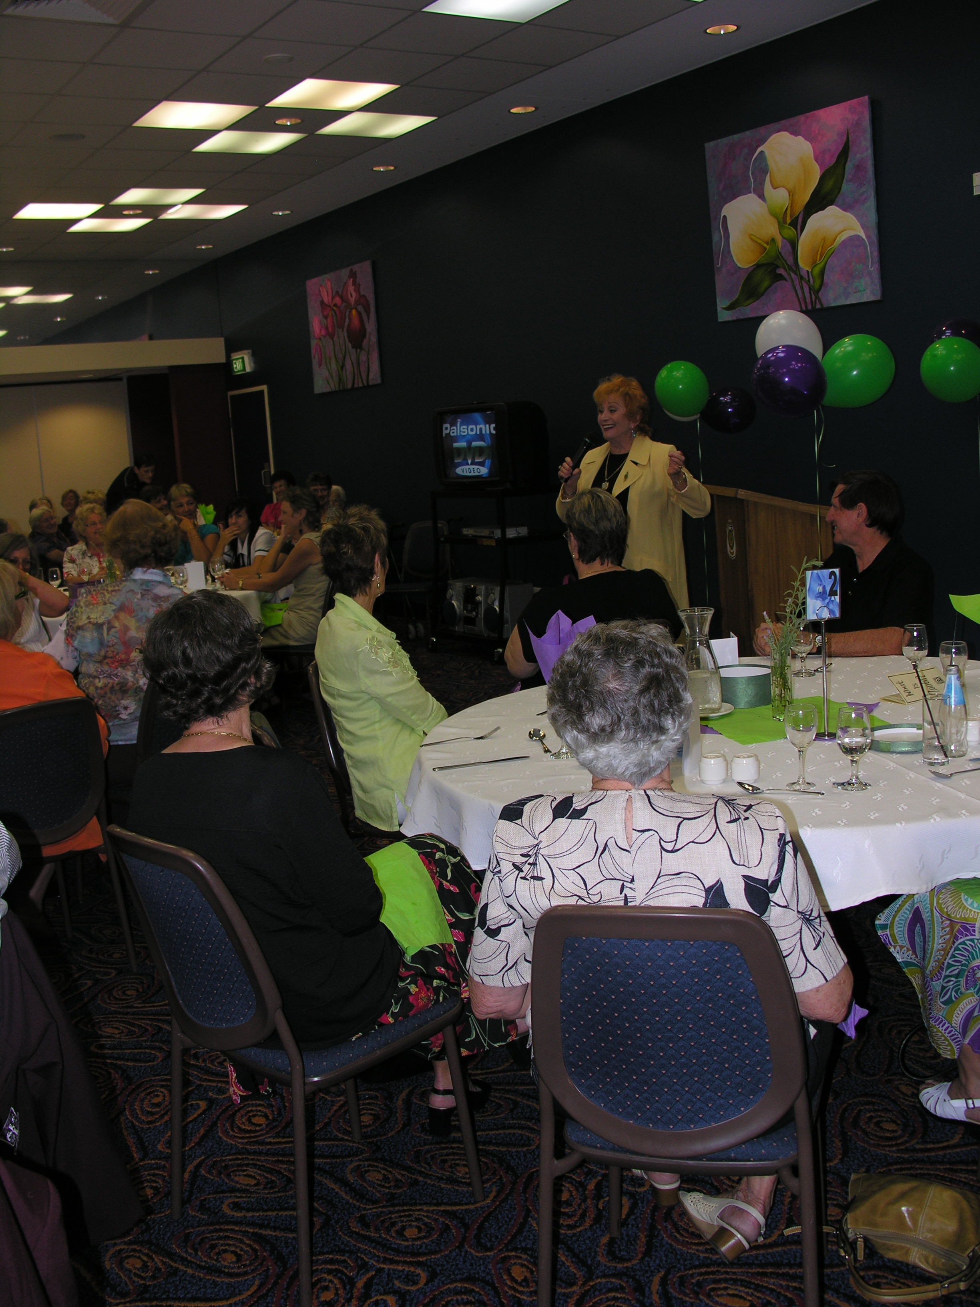
Hazel Phillips entertains the women at Zonta Club of Beaudesert’s IWD luncheon.

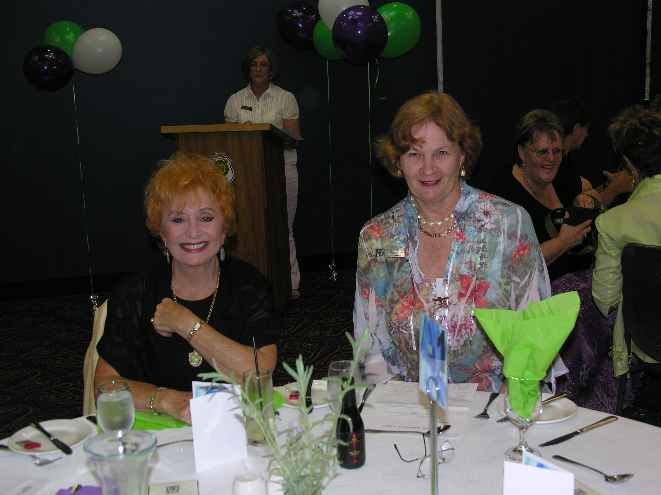
Hazel Phillips with President Alice Warby

