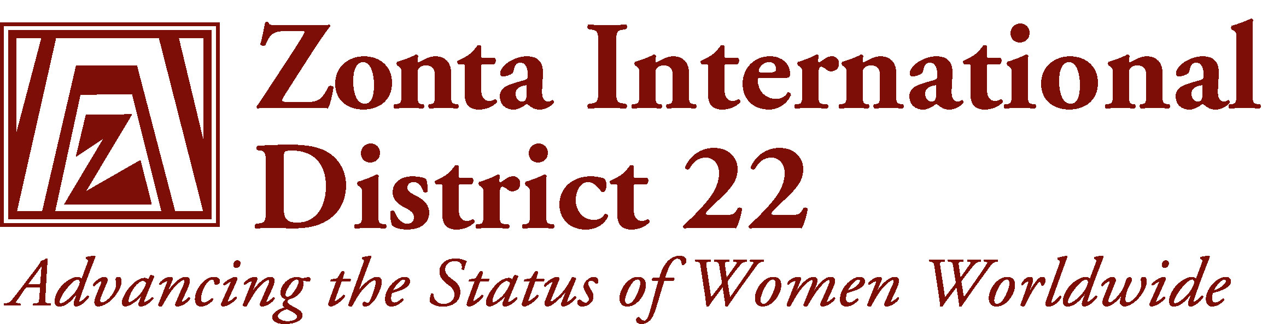
STATUS OF WOMEN
SERVICE COMMITTEE
2008-2010 GOALS
- To improve the legal, political, economic, educational, health and professional status of women
- To provide service at the local and global level
- To increase our commitment to service by the wise use of our time, talent and money

GUIDELINES FOR YOUR COMMITTEE
Young Women in Public Affairs

Amelia Earhart Award
Jane M Klausman Award
Legislative Awareness and Advocacy
Service - International

Local
ZISVAW - (see separate leaflet)
Z Clubs – (ZI Manual for Z Clubs)

District Chairman:

DUTIES of CLUB SWS CHAIRMEN
- Send your name and contact details to your District SWS Chairman
- Read Guidelines for Action and Biennial Goals in the Program Issue of the Zontian for the SWS Committee
- Make sure all projects "Advance the Status of Women"
- Survey Club members for suggestions for local Service projects.
- Investigate and recommend Club Service projects
- Set budget for all projects.
- Allow for 1/3rd of all Service funds raised to go to Zonta International for International Service projects.
- Organise your Committee projects with the Club Calendar so that events are spread throughout the year
- Evaluate each project in terms of the Status of Women Objective e.g. Funds raised
- Did it make a difference to the lives of women, if so - how many women?
- Did it raise the Status of these women? i.e. give the women skills to continue to improve their lives
- Short term or long term?
- Is it worth repeating the project?
- Did it raise the profile of Zonta?
- Keep a copy of all Committee Minutes and Events
- Prepare Annual Report for inclusion in President's Annual Report
- Send a copy to District SWS Service Chairman
- Complete the Footprint of Service Form

WHAT MAKES A GOOD SERVICE PROJECT?
A PROJECT TO:
- Enthuse and motivate all the club members
- Benefit a broad cross-section of the community
- Raise funds from the general public, not just the members
- Appeal to the media and public
- Reach a target that is realistic
- Enable easy planning
- Not involve too much time for each member
- Be planned well in advance, with clear delegation of duties
- Promote 'hands on' service as an alternative to fundraising
TIPS:
- Delegate inside and outside your Committee
- Involve other Committees in each project - Finance - to approve budget
- PR - for publicity, providing a guest speaker
- Membership - to look for new member contacts
- Consider forming sub-committees, for large functions
- Have a clear Status of Women Objective for each project, which all members understand
- Draw up a roster of duties well in advance
- Share duties among all members, not just the willing few
- Keep a copy of all arrangements for future functions
- Evaluate the success of each project

SERVICE/STATUS of WOMEN

HEALTH

SUGGESTED ACTIVITIES
- Consider a seminar for the community
- Raise funds for the local hospital/health project
- Raise community awareness for health issues, e.g. osteoporosis, fitness, mammograms
- Sponsor pamphlets on health issues

LITERACY
SUGGESTED ACTIVITIES
- Donate books/software to local schools/TAFE
- Run a Literacy competition for children
- Collect second-hand books or magazines, donate to refuges, hostels
- Volunteer to help with reading for children/women
- Volunteer to help with English conversation for women
- Read to aged people in nursing home care

AWARDS/SCHOLARSHIPS
SUGGESTED ACTIVITIES
Service:
- Recognise women for their community service
- School prizes to girls for community service
Status of Women:
- For talented women, mature age for retraining
- Woman of Achievement Awards
- School prizes, for girls furthering education
- Fund a talented girl to music/arts/sports camp/seminar
- Fund YWPA or J M Klausman winner to Alumnae Event

AMELIA EARHART DAY
SUGGESTED ACTIVITIES
- Celebrate Amelia Earhart’s Birthday- 11th January
- Hold a Club function - fellowship/fundraising
- Combine with other clubs in your Area for a Function
- Have a presentation on Amelia's life
- Invite a Fellowship winner as a guest speaker
- Invite a local pilot as guest speaker
- Hold the function at the airport/on a plane
- Have paper plane races
- Send proceeds from the function to ZI for Award Program
Amelia Earhart Websites:
www.tighar.org
www.ellensplace.net/eae_intr.html
www.cnmi-guide.com/history/ww2/amelia/index.htm

HAVE YOUR SAY !
AREA WORKSHOPS
2005, 2006
DISTRICT CONFERENCE
7th- 9th October 2005
CONTACT:
Your Area Director

District Chairman

SHARE YOUR STORIES:
Share your Club Newsletter with your Area Director for the Area Newsletter & with the District Chairman for District Website
www.zontadistrict24.org

ZI SCHOLARSHIPS/PROGRAMS
YOUNG WOMEN in PUBLIC AFFAIRS (YWPA)
Recognises commitment to the volunteer sector and to advancing the Status of Women, through interest in pursuing careers/leadership roles in community groups, public policy, or government
Awards:
Clubs decide on their own Prize, District Winner - US$500,
International Winner - US $1000
Eligibility:
For women 16-20 years of age who are pre-college or pre-university
Timeline:
Applications sent to Clubs in October Presidents Mailing Club Winner's name to District Governor by 1st March District Winner selected and notified to Zonta International by 15th April International Winner selected by 31st May

AMELIA EARHART FELLOWSHIP
Supports women pursuing post-graduate aerospace related sciences and engineering courses at university. Operated at International level only.
Award:
Approx 35 grants of US$6000 per year
Eligibility:
Completion of Bachelor's Degree in this area, Superior academic record
Evidence of a well-defined Research Program, clearly related to Aerospace sciences/engineering. Completion of one year of graduate study, by the time the fellowship is awarded.

ZI SCHOLARSHIPS/PROGRAMS (cont)
JANE M KLAUSMAN
WOMEN IN BUSINESS SCHOLARSHIP
To encourage undergraduate women to enter careers and seek leadership positions in business-related fields. Operates at Club, District and International level
Awards:
District Winner- A $750
International Winner- US $5000
Eligibility:
No age limit
Any woman entering the 3rd or final year of a business related undergraduate degree. Outstanding academic record. Intent to complete. Outstanding achievement in business related subjects Volunteer and leadership activities may also be considered
Timeline:
Applications sent to clubs in October Presidents Mailing
Club Winner selected and sent to District Governor by 31st May
District Winner selected and sent to ZI by 15th August
International Winners selected in September
************************
MORE INFORMATION/FORMS - for all AWARDS
Club maiIing - contact your President
SWS District Chairman
ZI Website- www.zonta.org
District Website – www.zontadistrict22.org

LEGISLATIVE AWARENESS and ADVOCACY
(Advocate - plead for, defend, recommend, support – Zontians
DO NOT lobby – they advocate)
What can you do?
- Appoint a spokesperson from your Committee
- Identify the issues that concern your members
- Plan realistic goals
- Educate your members about legislative awareness
- Explore the methods of advocacy with professionals eg parliamentarians, lobbyists, spokespersons, policy makers
- Decide on what issues the club would like to take action
- Observe the Zonta International and District 24 Policy and Protocol, if in doubt, contact your Area Director (both are available on the Zonta International and District 24 Websites
- Any publicity/action should be from the President, on behalf of the Zonta Club of .............
- Keep your Area Director informed of your actions
- Maintain a record of activities and achievements
- Encourage women to pursue opportunities in public and political arenas

