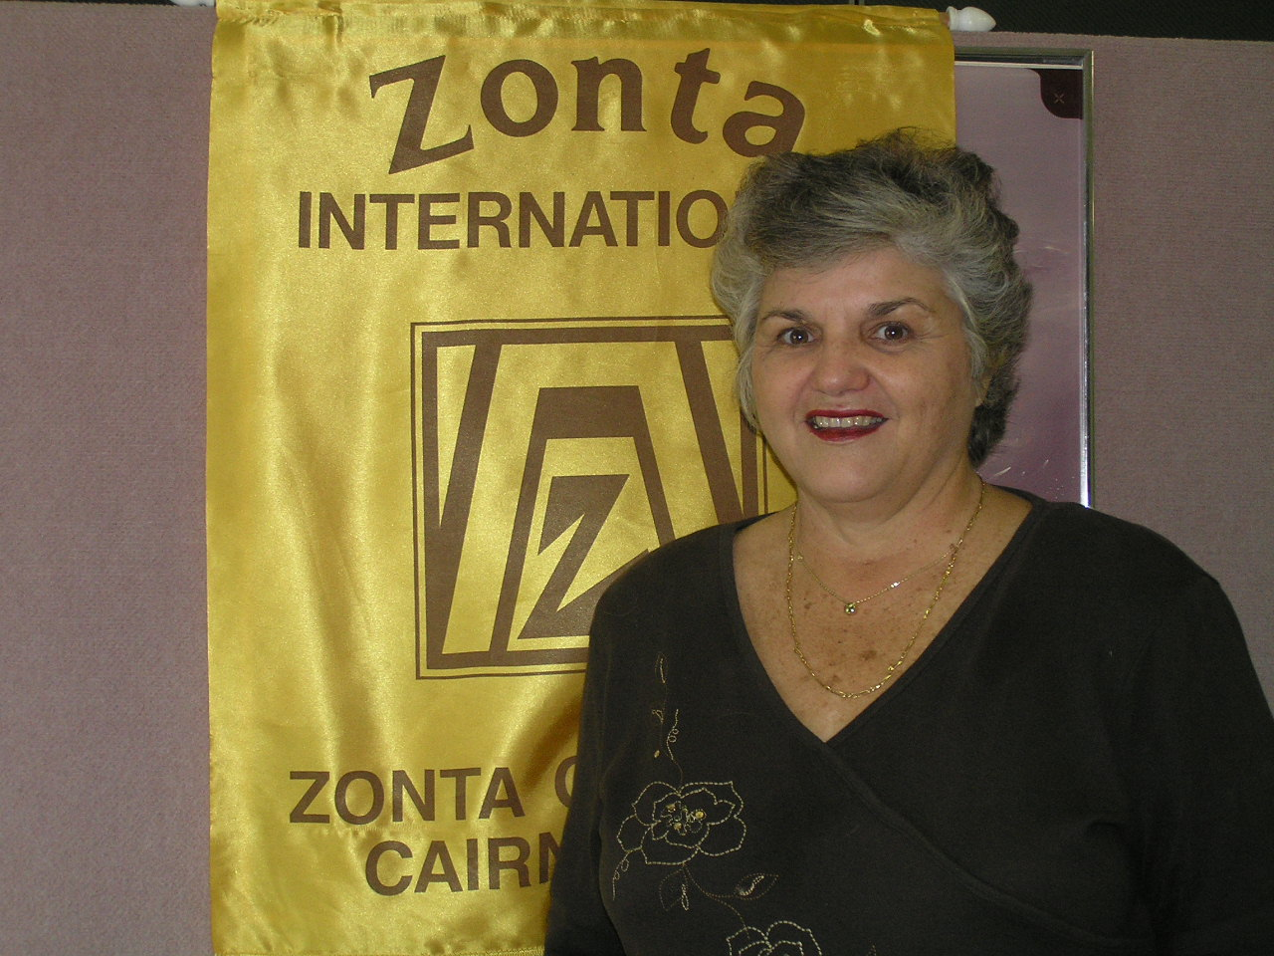

PRESIDENTS NEWSLETTER

Our Movie night has come and gone and I am pleased to say a great success. We must be doing something right when our guests keep arriving earlier and earlier which of cause makes it difficult to cater for everybody.
My thanks go to the Julie A. and her hard working committee for their input. I thought that the crowd enjoyed the movie in spite all its negative press.

I am sure Strawberries & Cream will take up most of our next dinner meeting so members please consider what you can do to assist. Time is fairly concentrated over that week but it is our major commitment for the year. A roster will go around at the meeting.

Functions have been arranged for the pre and post convention tours. Informal cocktail gatherings will be at Palm Cove on Wednesday 21st June and Wednesday 5th July. Cost will be $ 10.00 a head plus cash bar.
A good thought is that members could attend one or the other and for those members going out from the city a car pool would be a saving. There will be invitations available for all at the meeting.

Convention plans are in train and certainly Sally, Glennis, Ann and myself are looking forward to going even with the knowledge that it is going to be very cold. At last report there have been 1800 registered from 53 countries. At Shop we will be selling N.Q. coffee & tea, silk scarves and wildlife art from the very talented Daryl Dickson Luckily these do not appear to clash with what we know to also be on sale. We plan to dress up our table with tropical flowers to attract the northerns in from the cold.

Relay for Life will be over by the next dinner meeting but to those who are in the Zonta Dreamers I am sure they would have enjoyed themselves. These events are always good fun in spite of the long hours and sore feet.

Yours in fellowship through Zonta.

Lale M. Jones

DIARY DATES

3-4th June Relay for Life
Meeting at Barlow Park 1.00 p.m.

6th June Dinner Meeting – Sheridan Plaza
Book Night and CD’s

20th June Board Meeting – Yumi Smith’s

21st June Pre Convention Tour – Visiting
O/seas Zontians – Cocktails at
Stingers Beach Bar & Café, Palm Cove 6-7pm

24-29th June ZI Convention – Melbourne

5th July Post Convention Tour –same as
21st June

11th July Dinner meeting – Sheridan Plaza

18th July Board Meeting – Yumi Smith’s

19th-21st July Strawberries & Cream- Cairns Show

Apologies: All apologies for non-attendance for the Dinner Meeting for June, To be ‘phoned through to Lorraine on 4031-7400 by
Friday, 2nd 5.00 p.m.

Members News
Farewell to Lale, Anne G, Glennis and Sally Off to brrrrrrr Melbourne for International Convention. We look forward to hearing some wonderful anecdotes from these intrepid Travellers.

Quote for the Month

The achievements of an organisation are
the result of the combined effort of each individual.

GOODIES BASKET

Remember to bring along any donation of personal items to the next dinner meeting for Ruth’s women’s shelter.

COMMITTEE MEETING MINUTES

Finance Fundraising and United Nations

Meeting was held at 7.30am 11/05/2006 at the Ambulance Café.
Present; Janelle Charles, Susanne Jolly, Robyn Wakefield, Sally Graham.

Discussion on why members were taking leave of absence ??. Our committee now has 4 members. Members are selling their tickets for the Da Vinci Code. Janelle Charles is doing the Roster for Strawberries & Cream and will bring it to the next dinner meeting. Susanne Jolly has offered C’est Bon to the club for the next Melbourne Cup luncheon as a fund raiser. Thanks Susanne. BBQ at Bunnings in September. Could a member or committee come up with a fundraiser for next year ?? We would be interested in ideas.

Sally Graham

Organisation Classification & Membership

The meeting took place at the Corp Towers Coffee Shop on 11/05/2006 at 7.30am.
Present: Avril Bulstrode, Anne St.Martin, Glennis Webb, Paivi Pratley

Mary Skene and Helga Headrick have resigned from the Zonta club and our sub committee for personal reasons.
The three new prospective members were accepted by the Board and apparently by the other members by the newsletter. A letter will be sent inviting them to attend a dinner meeting. Two of the prospective members are away overseas at the time and a letter will be sent later on. If the prospective member is too busy, we will ask them to contact us in a few months time. We need to give Judy Noller, our newest Member a Zonta manual. Anne St. Martin will take care of this.

Our convention centered around the Zonta pre-convention and post convention Cairns activities. The Zoo was cancelled and it was decided to have platters of finger food at Apres at the beach, Palm Cove as the delegates will be staying next door. A flyer will be included with their pre –convention package. Avril will organize a Flyer “Finger foods & drinks on the Verandah”. The function will cost $10.00 and there will be a cash bar. We will need to organize a registration table, Zonta name tags with a yellow rose. This will be a chance to meet other Zontians. Time 7.00-8.00pm. The pre-convention function is the 21st June and the post convention function will be held on the 5th July. We do not know the exact numbers of delegates and partners at this time. We encourage all Cairns Zontians to attend and meet with other delegates.
Anne St. Martin (Chair)

P.S. venue has changed to Stingers Bar & Café 6-7 pm for the pre and post convention gathering.

Public Relations & Communications.

Meeting on Wed 10th May, at 7.30.a.m. at Tower Coffee Shop.

Present: Anne G, Yumi and Lorraine
Apologies, Julie A, Jan, Valerie and Julie J (LOA)

Discussion re Movie Night, Anne and Avril have produced a Flyer which was emailed to committee chairs. Anne has forwarded Notice to community noticeboards at Cairns Post, Cairns Sun,
Northern and Southern Newspapers, to Radio stations 846, SEA FM, Hot Fm, T.V. Stations ATN 7, WIN 9, Southern Cross 10. also Flyers to 10 ex Zontians. Anne has contacted Helga re PR equipment.
Anne has been updating our “brag Book” ready to take to Townsville Workshop, also “yellow” brochure and Web pages. Breast Care Posters
have been received from DG Ros and will be distributed to Zontians for distribution to Doctors Surgeries, Qld Cancer Fund, CBH, and Private Hospital.
Looking to update “Greatest Assets Board” with new member photos.

Next meeting Wed 15/6/06 – 7.30 a.m.
Meeting closed 8.20 a.m.

Status of Women.

Report not received at time of printing

Members Snippets

Sure to come back revitalized after attending the Townsville Workshop
Are Debbie S, Sally G, and Anne G. A great weekend with plenty of member participation.

Relay for Life: Sat/Sun 3-4/6/06 If you haven’t already advised Sally that you can assist at the Relay on Saturday, please do. Come along and encourage our Zonta team and do a few laps.

Welcome to New Member Judy Noller inducted at our last meeting. We hope you have many enjoyable hours with Zonta.

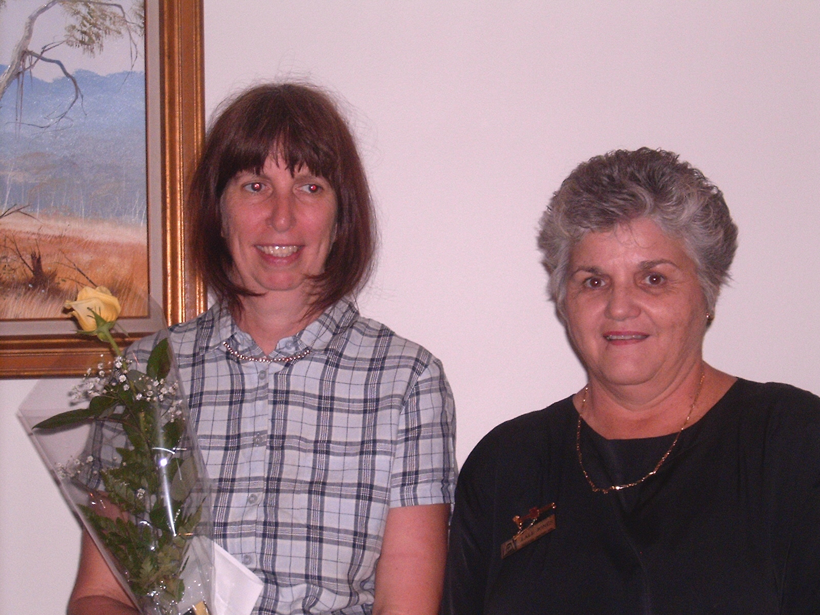

Books, Books, Books, CD’s, Don’t forget to bring along books and CD’s on 6th
June, the proceeds go towards our Literacy programs.

T Shirts Currently in stock a few sizes. See Lale $25.00. Remember you’ll need
One for Strawberries & Cream.

Computer Tips

Ladies when sending e mails – just a thought—on subject line – type in Zonta (for partners to print off for you) also flag emails to ensure that it’s received and read.

Newsletter articles

If possible please submit all newsletter contributions as a word document attached to your email to janigg@iig.com.au. This would be greatly appreciated. Please note Jan’s new Fax number 40547697.

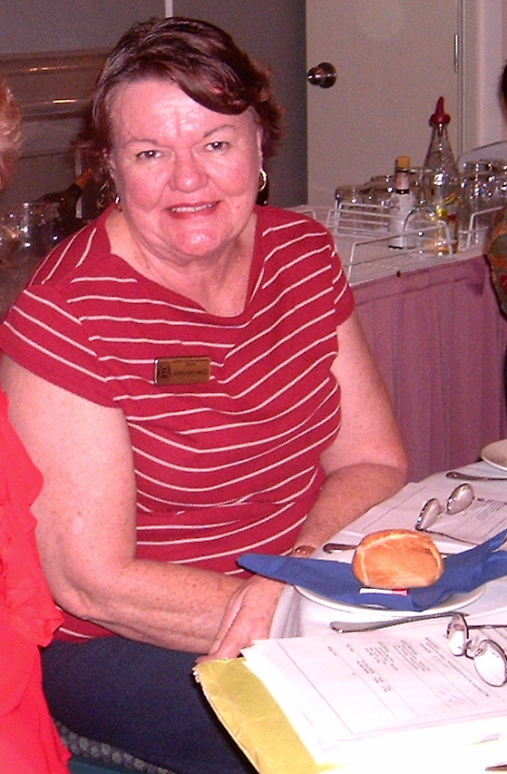

Margaret Bruce, a Zontian from the South Brisbane Zonta club spoke at our last Dinner meeting about her role in the recovery phase post cyclone Larry.

Movie Night – Well done Ladies

Another Successful Fund Raising event;
A good crowd, and comments from some
“Very thought provoking”;” Destroys some of the myths”; “Close to the Book”.
“Very engrossing”

CONVENTION NEWS

Some information just received. Our 4 Zontians will get to meet Kirsty Sword Gusmao – you recall we forwarded US $2000.00 to her in East Timor for the Mother’s support group. She will be presenting a workshop “Education for Women & Girls.
So far some 1800 Zontians from 53 Countries are attending -13 from Burkina Faso, 3 from Liechtenstein and 42 from Thailand. Can’t wait to see them all in their National costumes.

