BEAUZONTIAN

PO Box 174, BEAUDESERT QLD 4285
AREA 5.......DISTRICT 24
ISSUE 205 SEPTEMBER, 2005

GENERAL DINNER MEETING

Beaudesert RSL Club
William Street Beaudesert

Tuesday 20 September, 2005

Cost of Dinner $20 (GST inclusive)-Please try to have correct change.

Committee Meetings –
Board Meetings start at 5.00pm, Committees will meet at 5.45pm, prior to Dinner Meeting at 6.30pm.

APOLOGIES
Apologies are to be directed ONLY to Geraldine Collins on 55412058.
Please advise by 11am Monday 19 September, 2005.
In case of an EMERGENCY, an apology may be accepted by Geraldine up to 8.30am on day of the meeting. An account for the cost of the dinner will be forwarded to any member not responding in the usual manner.

MISSION STATEMENT
Zonta International is a worldwide service
organisation of executives in business and the professions
working together to advance the status of women.

From our President:

Dear Members

How quickly time passes when deadlines are looming!

Since our last meeting in August, The Building Your Future Workshop was presented, the Hospital Canteen, Telecross and other Footprints of Service have continued according to our commitments to our community. As well, members, Joan Gray, Joan Wilderspin, Ellen Logan and family members Jim and Timothy participated in the “Run for Cure” on Sunday 11 September and this Sunday, 18th is Swapmeet at the Showgrounds.

By the time you receive your newsletter the Swapmeet will be over. The response from members has been enlightening to say the least. People I have spoken to have had great difficulty deciding “what to keep or not to keep”. However, I’m sure that the day will be successful with Sue and Bob Topping opening the stall at 6.00am. Do you realize that it is a 5.00am start for them! Well done Sue and Bob.
The other sub-committee members have been busy collecting and organizing “objects d’arte” and pricing. Judy, Jane Struss and Alice and other rostered members should have a great day, not only fundraising but a fun day as well. We all have to practice our bartering! A big thank you to husbands and partners who will be negotiating the “heavy stuff” on the day.

At our last Dinner Meeting our guest speakers, one of our members Sue Topping, spoke about her holiday in the Northern Territory. Photograph and explanations of the conditions and the beauty of the Territory was inspiring whilst Lisa Qualischefski, from Debra Wilson Consulting Services for the Beaudesert Shire Council, encouraged a vociferous discussion about our future within the shire. Lisa went away with quite a few suggestions for the Council to consider. Well done every one who participated and spoke with experience and knowledge of rural living. Congratulations to the Program and PR Committee for organizing such a spirited evening.

The Beaudesert Show always provides the community with a spectacle but for some it requires a lot of preparation and planning. One such person, our very own Sue Smith, each year provides an educational program called Ag-Ed, for school students of all ages. With the help of Bernie, her husband, and a small band of volunteers, the program aims at educating children from the township or already on farms, about animals, small crops and the safety aspects for all farming activities being conducted within our Shire. Please read the feature article on Sue to fully appreciate the busy life of one of our own members.

Our next Dinner Meeting will be held at the Sports Centre, Peterson Road, the Board will meet at 5.00pm, the Committee Meetings at 5.45pm and the Dinner Meeting at 6.30pm. Remember the RSL is undergoing more renovations.

For those members on holiday, have a great break and come back refreshed, ready for the District Conference in October, preparations for the Gourmet Goodies Stall (Chaplaincy sponsorship) our last fundraiser for the year and finally, our Xmas Party in November.

Cheers

Sylvia

BIRTHDAY GREETINGS

SEPTEMBER
Special birthday greetings to all who are celebrating birthdays during this month. Especially to:
Catherine Drynan 10 September
Ellen Logan 25 September

DATES TO REMEMBER
BOARD and DINNER MEETINGS
20 September
18 October
15 November
OTHER IMPORTANT DATES
18 September Swapmeet
7-9 October District 24 Conference

OUR CLUB HAS A HEART
…..and new members are the life-blood of Zonta, we need to be constantly building on membership and it is the responsibility of each member to introduce new members.

New Member Protocol
- Obtain and complete Prospective Membership Form
- Forward to Membership Committee who checks available classification of prospective member.
- Present name/s and classification details to Board for approval when approval granted send invitation to join the club. If prospective member accepts invitation to join, fill out members report form and send copies and dues to District and Zonta International.
- Enter new member in membership Club book together with her details.
- Organize Induction ceremony and present Zonta pin and name badge.
Jane Struss - Membership
!

BUILDING YOUR FUTURE WORKSHOP - REPORT
The Biennial Zonta Building Your Future Workshop for young women, was held on Saturday 27 August at the St. Thomas Church Hall.

Thirty-two Year 10 and 11 students from three local high schools, Beaudesert, Mount Tamborine and The Kooralbyn International School attended the workshop from 8.45am to 4.00pm.

The aim of the workshop was to help young women be prepared for the workforce or further education, by encouraging them to be aware of the many choices they will have to make in the future.

Presenters on the day spoke about safety in the workplace and community, fitness, personal health issues, nutrition and food preparation. As well, a segment on financial planning and budgeting introduced the participants to managing their money to achieve their financial goals when living away from home.

Valuable advice was given in presenting resumes, how to dress and makeup to attend job interviews.
Another important aspect of life after school was the ability to communicate clearly in the workplace or educational fields.

One presenter, Ainsley Blunck, spoke about her life after school, university, being able to travel and work overseas and the many options available to her as a result of initial choices and achieving her goals.

Morning tea, lunch, and afternoon teas were prepared and presented by our members, Again, the purpose of the selected menus showed the participants, that the food and drinks offered were appetising, nutritional, cheap and could be presented in an attractive manner.

The participants were given a padded cooler bag filled with leaflets and brochures covering all aspects of the sessions, as well as makeup, skin products, a diary and calculator and pens, and a CD Rom due to the generosity of the sponsors. (See Separate List).

Evaluation Sheets were completed and these indicated that each participant learnt about the various issues that they would be confronting and most importantly becoming aware of choices to be made to give direction to their future.

Many thanks to the Building Your Future Workshop Sub-Committee and members who organized the setting up and cleaning of the hall on Friday and Saturday, cooking and preparing the refreshments and providing assistance where necessary to make this event a great success for the young women in the community who showed their appreciation at the end of the day.

Committee and Members include Judy Manderson (Coordinator), Alice Warby, Sister Catherina, Sue Topping, Joan Gray, Robin Powell, Sue Smith, Margaret Brennan, Jane Blunck, Gerry Gimblett, Geraldine Collins and Robyn Lincez.
Acknowledgement is given to the wonderful local, Brisbane sponsors and presenters on the day.
They are:
The Beaudesert Return Soldiers Leagues Club,
Beaudesert Medical Centre Pharmacy,
Pauls Limited,
Alberto Culver Pty. Ltd.,
Beaudesert Hospital Health/Dental Units, Johnson and Johnson,
Waldrons Optometrists,
Scenic Rim Insurances,
Shays Pharmacy,
Beaudesert Prescription Centre,
Jimboomba Pharmacy and
Mission Australia
Sylvia

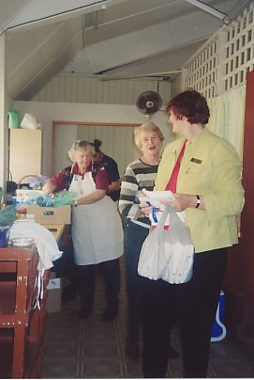
Hard at work, and having a great time – from rear:
Sue Topping, Sister Catharina, Joan Gray and Alice Warby, at the Building Your Future Workshop.

FROM THE ARCHIVES - 10 YEARS
Ten years ago in September, 1995, we:
- Manned the Trash and Treasure Stall at the Wongaburra Spring Fair
- Heather Waldron reported that 280 tickets had been for sale for the Jazz Night to be held at Nindooinbah
- Coralie Clarke reported that the Golf Day held at Hills had been a terrific success.
Thanks to Robin P.
LIFE
“Life should NOT be a journey to the grave with the intention of arriving safely in an attractive and well preserved body, but to rather skid sideways, Champagne in one hand – strawberries in the other, body thoroughly used up, totally worn out, and screaming WOO-HOO – What a Ride!”
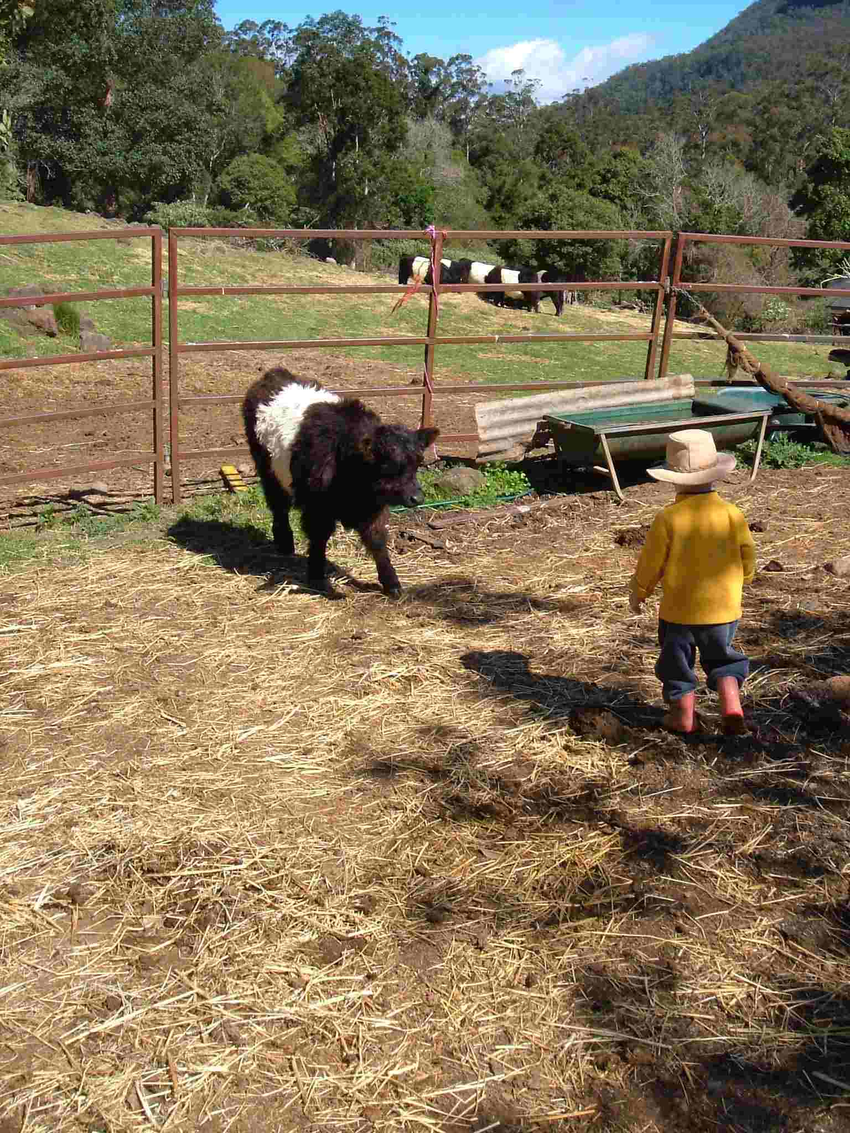

Sue Smith, Newsletter Editor, news hunter and gatherer, ringer-up and reminder, cut-and-paster divides her time fairly evenly between her eighteen grandchildren and her eighteen (or so) stud Belted Galloways. She enjoys an occasional day’s teaching at her beloved Darlington State School, as well as managing assorted sheep, geese, guinea fowl, chooks (and a husband) on their property, Yarabilgong, on the upper reaches of Christmas Creek.
As their place works on alternative energy (solar in the drought, hydro in the non-
drought), and drinking water from the creek, Sue sometimes gets the Newsletter out using a combination of message stick, carrier pigeon and smoke signals from the combustion stove.
With Lamington National Park for a neighbour, Sue has frequent meetings with platypus, echidna, scrub turkey, black cockatoo, king parrot, wedge-tailed eagle and carpet snake.
She thanks recipients for their patience and forbearance with her sometimes erratic newsletter production.
PRESIDENTS MEETING REPORT
At the Committee Meetings, a report from the Presidents’ and Board members Meeting held on the day of our Building Your Future Workshop will be distributed for your information. This was emailed by the Area Director, Vicki Varthas, who presented our apologies for not being able to attend, and filled a request from our President, to have any valuable information forwarded to our Club.
Here is the challenge!!!
Could each Committee discuss their goals and service project priorities for the biennium, present it in the Committee Reports at the Dinner Meeting and then the Board can provide a summary for the Area Director, the Zontian and a reminder to us why we are members of a very special club.
Many thanks.
Sylvia

